**ABSTRACT**

Water is one of the most vital elements for livelihood but at the same time, it is polluted by different kinds of fastest-growing industries like textiles, leather, sugar, etc. The textile industry is one of the most water-consuming sectors. A huge amount of water is being used in different textile processes and consequently, a high volume of contaminated water is being produced. Both the textile processes, machinery, and environment are very sensitive to water parameters. There are significant numbers of water quality monitoring systems available that are very costly, have no notification system for critical conditions, and are also not automated.

To mitigate these problems, we propose a low-cost IOT-based automatic water quality monitoring system that provides real-time information about water parameters and transmits data through node MCU and relay module. Real-world evaluation of our system shows that wastewater from the washing and untreated dyeing process has high-level contamination compared with usable water. The device can detect the abnormal value of different parameters such as turbidity sensor with turbidity meter and DTH11 sensor when contaminated water gets mixed with usual water and alarm the personnel through email and SMS. The device can be used to monitor the quality of water for any specific water-sensitive process and condition of the treatment plan.

# 

# CHAPTER - 1

**INTRODUCTION**

## OVERVIEW

The textile industry is one of the major contributors to water pollution due to the large amounts of water used in the manufacturing process. To address this issue, water quality monitoring systems can be implemented using sensors such as the turbidity sensor and DTH11 sensor. The turbidity sensor measures the amount of suspended solids in the water, which can indicate the level of contamination. The DTH11 sensor, on the other hand, measures the temperature and humidity of the environment around the sensor.

NodeMCU, an open-source firmware and development kit based on the ESP8266 WIFI module, can be used as the main controller for the monitoring system. It can communicate with the sensors and send the data to a server or a cloud platform for storage and analysis.By continuously monitoring the water quality in the textile industry using this system, companies can take necessary steps to reduce their environmental impact and comply with regulations. This can include adjusting the amount of chemicals used in the manufacturing process, implementing filtration systems, or reducing water usage.

* 1. **TEXTILE INDUSTRY WATER QUALITY MONITORING**

Polluted water causes different kinds of problems for human beings, animals, plants, and all other living beings. Urbanization and industrialization are increasing enormously with the proportionate rate of population growth. Environmental pollution is a major concern in the era of industrialization. Water pollution is one component of this pollution. Pollution of water can cause severe damage to our health, impair the fertility of the land, and harm the aquatic life. Industrial waste materials are one of the prime causes of water pollution. Textile dyeing is the second severest cause for water pollution globally, and the fashion industry produces 20% of the world’s wastewater. In the manufacturing of clothing and household appliances, manufacturers’ extensive water consumption and sanitation activities pollute soil and groundwater which negatively impact the environment, affecting ecosystems, and animal and human food chains. About 72 toxic chemicals can get mixed in the waterway while dyeing the fabric.

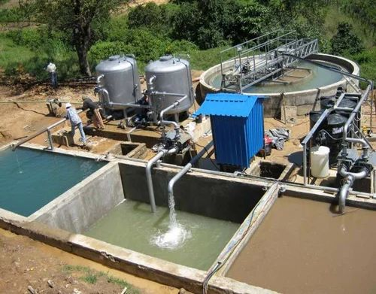

Fig -1.1

Textile Industry Water Quality monitoring

These chemicals harm water and the entire ecosystem, exposing us to harmful chemicals and making us vulnerable to the resultant health hazards. Recently, Bangladesh has achieved impetuous economic growth, and its target is to become a middle-income country by 2021. This sector comprises about 45% of our workforce. This textile industry is an excellent locomotive for promoting the economic development of Bangladesh. These garments sector contributes to the 82% of the country’s total export revenues, that is, about $28 billion a year. Currently, more than 3000 garment factories are located in Dhaka, according to the government database.

It is estimated wastewater emitted from these garment industries was about 217 million litres, and by the end of 2021, it will reach about 349 million litres. Industrial wastes and wastewater contain heavy metals such as vanadium, molybdenum, zinc, nickel, mercury, lead, copper, chromium, cadmium, and arsenic is polluted water is used for irrigation in cultivated lands, paddy fields, vegetable growing fields, and other farming sources near industrial areas. Food poisoning, diarrhea, short-term gastrointestinal problems, respiratory diseases, skin problems, and some other severe health complications can be caused by this polluted water. It may have long-term consequences for our bodies. So, we can clearly understand that the textile industry is such a sector that has a long-term impact on our economy.

Hence, we need to find a solution to mitigate the risk factors by characterizing the water quality parameters. For this, we chose to measure the pH, temperature of water. In search of some techniques for finding out the values of water quality parameters in the literature and some sensors only in we found an advanced approach for water quality measurement. Here, the researchers designed a package system built with a controller and other sensors, using some different and alternative sensing modules that can monitor and show real-time data.

As water quality classification models, the Recurrent Neural Network (RNN) and Long Short-Term Memory (LSTM) neural network techniques are used, machine learning was aligned with IOT devices to sense and analyse water quality factors. We found the use of Node MCU module in, which is an old approach; the instrument is costly and currently less available in the market. We also found the use of measuring water quality parameters. Some basic approaches related to our work have been found in, as they added extra value to the monitoring system with their floating feature with a device that can be sent to rivers or water sources to get real-time data. Measuring and providing safe drinking water was the goal of articles.

This proposed device/module detects solids, particles, gases, and other molecules dissolved into or separated from the wastewater emitted from the textile industry. Using our system, industry authorities can easily reduce the use of these elements in their chemicals or other materials that are mandatory in producing garment items. In this case, we fixed fundamental parameters for measuring water quality: turbidity, and DTH11 temperature. These following is a breakdown of the study’s structure: These methods and methodologies for the study including outline of the system and details of the hardware materials, sensors, and working flowchart are discussed. This focuses on the results of the study based on the analyses of the real-time data from the sensors. Finally, the research is summarized and the importance of safe water for living beings is discussed, which finally concludes with future direction for this work.

## 1.3. AIM OF THE PROJECT

The aim of using a water quality monitoring system in the textile industry is to provide real-time information on the quality of the water used in the manufacturing process. This can help textile companies to:

1.Monitor the level of pollution in their wastewater discharge and ensure compliance with regulatory standards.

2.Identify potential issues with the manufacturing process that may lead to water contamination and take necessary corrective actions.

3.Improve water management practices by identifying areas where water conservation can be implemented.

4.Reduce the environmental impact of their operations by minimizing water pollution.

The goal is to help textile companies operate more sustainably by minimizing their impact on the environment and complying with regulatory standards. By using a water quality monitoring system, textile companies can ensure that their operations are sustainable and responsible.

**1.4 APPLICATIONS**

The application of a water quality monitoring system in the textile industry is broad and diverse. Some of the applications are:

1.Real-time monitoring of water quality parameters such as turbidity, temperature, and humidity.

2.Identification of water quality issues and early detection of potential problems in the manufacturing process.

3.Reduction in water usage by identifying areas where water conservation can be implemented.

4.Compliance with regulatory standards for wastewater discharge.

5.Optimization of manufacturing processes to minimize environmental impact.

6.Data analysis and visualization for decision-making purposes.

7.Providing stakeholders with transparent data on water quality in the textile industry to ensure sustainable and responsible operations.

The system can also be used in other industries that require water quality monitoring, such as food and beverage, pharmaceuticals, and chemical manufacturing.

**1.5. RESEARCH:**

Investigating the performance of turbidity sensors and DTH11 sensors in measuring water quality parameters such as turbidity, temperature, and humidity and evaluating the accuracy of the water quality monitoring system and the effect of environmental factors on the measurement results. Investigating the impact of the water quality monitoring system on textile manufacturing processes and the potential for cost savings and environmental benefits, Comparing the performance of different water quality monitoring systems and sensors for the textile industry.

# CHAPTER – 2

# 

# 2.1 LITERATURE REVIEW

A literature survey of textile industry water quality monitoring systems using IoT reveals the following previously proposed systems:

IOT-based Water Quality Monitoring System for Textile Industry: This system proposed by Hui et al. (2018) uses an IoT platform to monitor the water quality in textile wastewater treatment plants. The system consists of sensors to collect data on water quality parameters, a cloud server for data storage and analysis, and a user interface to display the data.

IOT-based Water Quality Monitoring System for Dyeing Industry: This system proposed by Gao et al. (2019) uses a wireless sensor network to monitor the water quality in a dyeing industry. The system consists of sensors to collect data on water quality parameters, a gateway to transmit the data, and a cloud server for data storage and analysis.

IOT-based Water Quality Monitoring System for Textile Wastewater Treatment Plant: This system proposed by Wang et al. (2020) uses an IoT platform to monitor the water quality in a textile wastewater treatment plant. The system consists of sensors to collect data on water quality parameters, a gateway to transmit the data, and a cloud server for data storage and analysis.

IOT-based Water Quality Monitoring System for Textile Dyeing Wastewater: This system proposed by Lietal. (2018) uses a wireless sensor network to monitor the water quality in textile dyeing wastewater. The system consists of sensors to collect data on water quality parameters, a gateway to transmit the data, and a cloud server for data storage and analysis.

Overall, these previously proposed systems demonstrate the effectiveness of IoT-based water quality monitoring systems in the textile industry. They provide real-time data, are cost-effective, easy to install and maintain, and can be accessed remotely. However, further research is needed to address the challenges associated with their implementation and to optimize their performance.

**2.2 PROBLEM STATEMENT**

The textile industry is one of the largest consumers of water, which makes it important to monitor the quality of water used in the production process. Traditional methods of water quality monitoring are manual, time-consuming, and often inaccurate. This poses a significant challenge to textile industries that are concerned about the quality of their products and the environmental impact of their operations.

Implementing an IoT-based water quality monitoring system can provide real-time data on water quality, enabling textile industries to ensure the quality of their products and minimize their impact on the environment. This system can be designed to monitor various parameters such as pH, turbidity, temperature, and dissolved oxygen levels. The system can be equipped with sensors that measure these parameters and transmit the data wirelessly to a central server. The server can then process the data and generate alerts if any parameters fall outside of the acceptable range. Real-time monitoring: With an IOT-based water quality monitoring system, textile industries can monitor the quality of water used in their production processes in real-time, enabling them to take immediate action if any parameters fall outside of the acceptable range.

# 

# 

**CHAPTER-3**

**HARDWARE COMPONENTS**

## 

## 3.1 NODE MCU

The name "NodeMCU" combines "node" and "MCU" (micro-controller unit). Strictly speaking, the term "NodeMCU" refers to the firmware rather than the associated development kits. Both the firmware and prototyping board designs are open source.

The ESP8266, designed and manufactured by Express - if Systems, contains the crucial elements of a computer: CPU, RAM, networking (Wi-Fi), and even a modern operating system and SDK. That makes it an excellent choice for Internet of Things (IoT) projects of all kinds.

Node MCU is an open-source firmware for which open source [prototyping](https://en.wikipedia.org/wiki/Prototyping) board designs are available. The term "NodeMCU" strictly speaking refers to the firmware rather than the associated [development kits.](https://en.wikipedia.org/wiki/Development_kits)

The firmware uses the [Lua](https://en.wikipedia.org/wiki/Lua_(programming_language)) scripting language. The firmware is based on the Lua project, and built on the express if Non-OS SDK for ESP8266. It uses many opensource projects, such as Lua and [SPIFFS](https://en.wikipedia.org/w/index.php?title=SPIFFS&action=edit&redlink=1) .

Due to resource constraints, users need to select the modules relevant for their project and build a firmware tailored to their needs. Support for the 32-bit [ESP32](https://en.wikipedia.org/wiki/ESP32) has also been implemented.

However, as a chip, the ESP8266 is also hard to access and use. You must solder wires, with the appropriate Analog voltage, to its pins for the simplest tasks such as powering it on or sending a keystroke to the “computer” on the chip. You also have to program it in low-level machine instructions that can be interpreted by the chip hardware.

This level of integration is not a problem using the ESP8266 as an embedded controller chip in mass-produced electronics. It is a huge burden for hobbyists, hackers, or students who want to experiment with it in their own IoT projects.

**VERSIONS OF NODEMCU**

1.NodeMCU v0.9 - The first version of the NodeMCU Wi - Fi module was released in 2014 and was based on the ESP8266-12E module. It featured an onboard ESP8266 WIFI chip, a USB to UART converter, and a voltage regulator.

2.NodeMCU v1.0 - The second version of the NodeMCU Wi-Fi module was released in 2015 and featured several improvements over the first version. It had a more compact design, a larger flash memory (4MB), and more GPIO pins.

3.NodeMCU v2 - The third version of the NodeMCU Wi-Fi module was released in 2016 and featured an upgraded ESP8266-12F module with better power management and improved RF performance.

4.NodeMCU v3 - The fourth version of the NodeMCU Wi-Fi module was released in 2017 and was based on the ESP-12S module. It had more flash memory (16MB), an improved voltage regulator, and more GPIO pins.

**HISTORY OF NODE MCU**

NodeMCU was December 30, 2013, [Espressif Systems](https://en.wikipedia.org/w/index.php?title=Espressif_Systems&action=edit&redlink=1) began production of the ESP8266. NodeMCU started on 13 Oct 2014, when Hong committed the first file of NodeMCU-firmware to GitHub. Two months later, the project expanded to include an open-hardware platform when developer Huang R committed the [Gerber](https://en.wikipedia.org/wiki/Gerber_format) file of an ESP8266 board, named devkit v0.9. Later that month, Tuan PM ported [MQTT](https://en.wikipedia.org/wiki/MQTT) client library from [Contiki](https://en.wikipedia.org/wiki/Contiki) to the ESP8266 SoC platform,[[15]](https://en.wikipedia.org/wiki/NodeMCU#cite_note-mqtt_client-15) and committed to NodeMCU project, then NodeMCU was able to support the MQTT IoT protocol, using Lua to access the MQTT broker. Another important update was made on 30 Jan 2015, when Devsaurus ported the u8glib to the NodeMCU project, enabling NodeMCU to easily drive LCD, Screen, OLED, even VGA displays.

In the summer of 2015, the original creators abandoned the firmware project and a group of independent contributors took over. By the summer of 2016 the NodeMCU included more than 40 different modules.

**3.1.1 PINS:**

NodeMCU provides access to the [GPIO](https://en.wikipedia.org/wiki/General-purpose_input/output) (General Purpose Input/Output) and a pin mapping table is part of the API documentation.

|  |  |
| --- | --- |
| **I/O index** | **NodeMCU**  **pin** |
| 0 [*] | GPIO16 |
| 1 | GPIO5 |
| 2 | GPIO4 |
| 3 | GPIO0 |
| 4 | GPIO2 |
| 5 | GPIO14 |
| 6 | GPIO12 |
| 7 | GPIO13 |
| 8 | GPIO15 |
| 9 | GPIO3 |
| 10 | GPIO1 |
| 11 | GPIO9 |
| 12 | GPIO10 |

Table –3.1 NodeMCU pins

**3.1.2 USES:**

NodeMCU is an open-source platform based on ESP8266 which can connect objects and let data transfer using the Wi-Fi protocol. In addition, by providing some of the most important features of microcontrollers such as GPIO, PWM, ADC, and etc, it can solve many of the project's needs alone.

## 

## 3.1.3 FEATURES AND SPECIFICATIONS

1. Low-cost open-source software.
2. Software - Lua scripting language.
3. Memory - 128KB.
4. Storage - 4MB.
5. Power – USB.
6. GPI/O – 16pins.
7. ISM - 2.4GHz.
8. Operating Voltage - 3.3v.
9. Temperature Range - -40C – 125C.

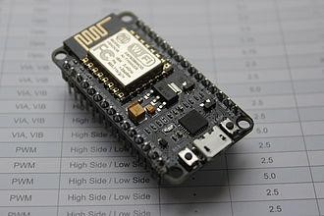

Fig – 3.1 NODE MCU

### 3.2 ESP8266

The ESP8266 is a low-cost [Wi-Fi](https://en.wikipedia.org/wiki/Wi-Fi) microchip, with built-in [TCP/IP networking software,](https://en.wikipedia.org/wiki/TCP/IP_stack) and [microcontroller](https://en.wikipedia.org/wiki/Microcontroller) capability, produced by [Express if Systems](https://en.wikipedia.org/w/index.php?title=Espressif_Systems&action=edit&redlink=1) in Shanghai, China. The chip was popularized in the English-speaking [maker](https://en.wikipedia.org/wiki/Maker_culture) community in August 2014 via the ESP-01 module, made by a third-party manufacturer Ai-Thinker. This small module allows microcontrollers to connect to a Wi-Fi network and make simple TCP/IP connections using [Hayes-](https://en.wikipedia.org/wiki/Hayes_command_set)style commands.

However, at first, there was almost no English-language documentation on the chip and the commands it accepted. The very low price and the fact that there were very few external components on the module, which suggested that it could eventually be very inexpensive in volume, attracted many hackers to explore the module, the chip, and the software on it, as well as to translate the Chinese documentation.

The ESP8285 is a similar chip with a built-in 1 MiB flash memory, allowing the design of single-chip devices capable of connecting via Wi-Fi. The ESP8266 module works with 3.3V only, anything more than 3.7V would kill the module hence be cautions with your circuits. The best way to program an ESP-01 is by using the FTDI board that supports 3.3V programming. If you don’t have one it is recommended to buy one or for, time being you can also use an Arduino board. One commonly problem that everyone faces with ESP-01 is the powering up problem. The module is a bit power hungry while programming and hence you can power it with a 3.3V pin on Arduino or just use a potential divider.

So, it is important to make a small voltage regulator for 3.31v that could supply a minimum of 500mA. One recommended regulator is the [LM317](https://components101.com/lm317-pinout-equivalent-datasheet) which could handle the job easily. A simplified circuit diagram for using the ESP8266-01 module is given below.

**ESP8266 VERSIONS**

The ESP8266 is a popular low-cost Wi-Fi module developed by Espressif Systems, a Chinese manufacturer of microcontroller chips. There are several versions of the ESP8266, each with different features and capabilities. Here are some of the most common versions:

ESP-01: This is the original version of the ESP8266 module and has a small form factor. It features a built-in Wi-Fi antenna, 1MB of flash memory, and UART communication interface.

ESP-12E: This version of the ESP8266 has more GPIO pins than the ESP-01, which makes it more versatile. It has 4MB of flash memory and a built-in ceramic antenna.

ESP-12F: Similar to the ESP-12E, but with improved Wi-Fi performance and a smaller form factor. It also has a built-in ceramic antenna.

ESP-07: This version has a larger form factor than the ESP-01, with more GPIO pins and 2MB of flash memory. It also has a built-in PCB antenna.

ESP-WROOM-02: This module has a small form factor and comes with 2MB of flash memory. It has a built-in Wi-Fi antenna and a UART interface.

ESP-WROOM-32: This is a newer version of the ESP8266, which is based on the ESP32 chip. It features dual-core processors, Bluetooth and Wi-Fi connectivity, 4MB of flash memory, and a variety of other features. It has a larger form factor than the previous versions.

**HISTORY OF ESP8266**

As Arduino.cc began developing new MCU boards based on non-AVR processors like the ARM /SAM MCU and used in the Arduino Due, they needed to modify the Arduino IDE so that it would be relatively easy to change the IDE to support alternate toolchains to allow Arduino C/C++ to be compiled for these new processors. They did this with the introduction of the Board Manager and the SAM Core. A "core" is the collection of software components required by the Board Manager and the Arduino IDE to compile an Arduino C/C++ source file for the target MCU's machine language. Some ESP8266 enthusiasts developed an Arduino core for the ESP8266 Wi-Fi SoC, popularly called the "ESP8266 Core for the Arduino IDE"[.](https://en.wikipedia.org/wiki/NodeMCU#cite_note-16)

This has become a leading software development platform for the various ESP8266-based modules and development boards, including NodeMCU

**3.2.1 PINS:**

The [pinout](https://en.wikipedia.org/wiki/Pinout) is as follows for the common ESP-01 module:

1. GND, Ground (0 V)
2. GPIO 2, General-purpose input/output No. 2
3. GPIO 0, General-purpose input/output No. 0
4. RX, Receive data in, also GPIO3
5. VCC, Voltage (+3.3 V; can handle up to 3.6 V)
6. RST, Reset
7. CH_PD, Chip power-down
8. TX, Transmit data out, also GPIO1

**3.2.2 USES**:

The ESP8266 module enables microcontrollers to connect to 2.4 GHz Wi-Fi, using IEEE 802.11 bgn. It can be used with ESP-AT firmware to provide Wi-Fi connectivity to external host MCUs, or it can be used as a self-sufficient MCU by running an RTOS (Real Time Operating System) based SDK (software development kit).

## 3.2.3 FEATURES & SPECFICATIONS

1. Low-cost Wi – Fi microchip.
2. Built in TCP/IP protocol.
3. Micro controller – 32-bitStorage – 32KB.
4. Memory – 80KB.
5. Power – 3.3v.
6. GPI/O – 17pins.
7. Frequency range - 2.4GHz - 2.5GHZ.
8. Operating temperature range - -40 ° C ~ 125 ° C.

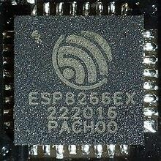

FIG – 3.2 ESP8266

### 3.3 TURBIDITY SENSOR

A turbidity sensor is a device used in water quality monitoring to measure the clarity of water by detecting the amount of suspended particles in it. Turbidity refers to the degree to which light is scattered by the particles present in water. Turbidity sensors work by shining a light through a water sample and measuring the amount of light that is scattered by the suspended particles in the water. The more particles there are in the water, the more light will be scattered, and the higher the turbidity reading will be. Turbidity sensors are used in a variety of applications, including monitoring drinking water quality, wastewater treatment, and environmental monitoring. They are particularly useful in detecting changes in water quality caused by changes in land use, runoff, or weather conditions

The use of turbidity sensors in water quality monitoring is important because it provides a quick and accurate way to assess the level of contamination or pollution in water. This information can be used to take appropriate measures to protect public health and the environment. The pins on a turbidity sensor depend on the specific model and manufacturer of the sensor. However, most turbidity sensors have at least two pins, a power pin and a signal pin. The power pin is used to provide power to the sensor. Typically, turbidity sensors operate at low voltage, and the power pin is connected to a power source, such as a battery or a power supply.

The signal pin is used to transmit the sensor's output signal to a microcontroller or other device for processing. The signal may be an analog voltage, which can be read by an analog-to-digital converter (ADC), or a digital signal, which can be read by a digital input pin. Some turbidity sensors may have additional pins for features such as temperature compensation or calibration. It's important to refer to the specific sensor's datasheet or documentation to determine the pin configuration and how to properly connect and use the sensor.

**WORKING OF TURBIDITY SENSOR**

A turbidity sensor is a device used to measure the amount of suspended particles in a liquid or gas. The basic working principle of a turbidity sensor involves shining a light through a sample of the liquid or gas being measured and then detecting the amount of light that is scattered by the suspended particles. The more particles there are, the more the light is scattered, and the higher the turbidity reading. There are different types of turbidity sensors, but most of them use one of two methods to measure turbidity: nephelometric or ratio turbidimetric.

Nephelometric turbidity sensors measure the amount of light scattered at a 90-degree angle to the incident light. This method is sensitive to smaller particle sizes and is often used in drinking water applications. Ratio turbidimetric sensors measure the amount of light scattered at an angle to the incident light and also measure the amount of light that is transmitted through the sample. This method is less sensitive to smaller particle sizes but can be used in a wider range of applications, including wastewater treatment.

In both methods, the amount of scattered or transmitted light is detected by a photodetector and converted into an electrical signal, which is then processed to provide a turbidity reading. Some sensors may also incorporate temperature and pressure compensation to ensure accurate readings under different conditions.

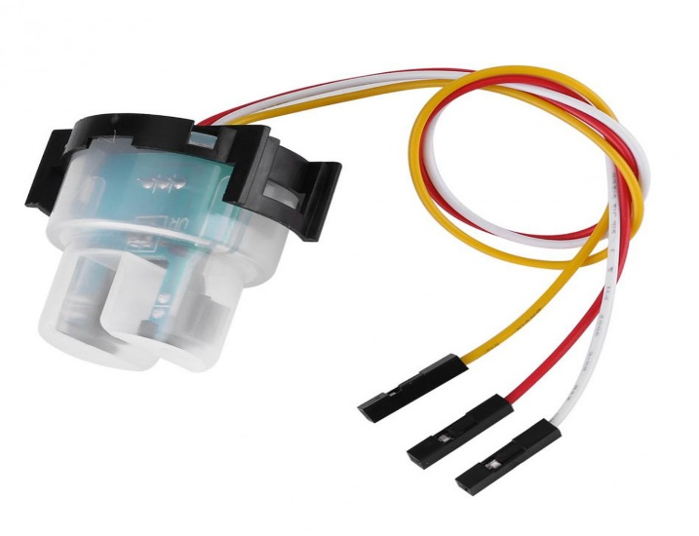

Fig-3.3 Turbidity sensor

**3.3.1. ADVANTAGES**

There are several advantages to using turbidity sensors for water quality monitoring:

1.Easy to use: Turbidity sensors are generally easy to use and require minimal training to operate. They can provide accurate and reliable readings with minimal user input.

2.Real-time monitoring: Turbidity sensors can provide real-time monitoring of water quality, allowing for rapid detection of changes in turbidity levels. This can help to identify potential issues before they become major problems.

3.Non-invasive: Turbidity sensors are non-invasive, meaning that they do not need to come into contact with the water being monitored. This reduces the risk of contamination and ensures that the water being monitored remains unaffected.

4.Cost-effective: Turbidity sensors are relatively inexpensive compared to other types of water quality monitoring equipment, making them an affordable option for many organizations.

5.Versatile: Turbidity sensors can be used in a variety of applications, including monitoring the quality of drinking water, wastewater treatment, and environmental monitoring. They can be used in both laboratory and field settings.

6.Accuracy: Turbidity sensors can provide highly accurate readings, with some sensors capable of measuring turbidity levels as low as 0.001 NTU (Nephelometric Turbidity Units).

Overall, turbidity sensors are a valuable tool for water quality monitoring, providing accurate, real-time data that can help to ensure the safety and quality of our water supply.

**APPLICATIONS**

Turbidity sensors are used in a variety of applications where the clarity or quality of a liquid needs to be monitored. Here are some common applications of turbidity sensors:

1.Drinking water treatment: Turbidity sensors are often used in drinking water treatment plants to monitor the level of suspended solids and ensure that the water is safe for consumption.

2.Wastewater treatment: In wastewater treatment plants, turbidity sensors are used to monitor the level of suspended solids in the effluent water before it is released into the environment.

3.Food and beverage industry: Turbidity sensors are used to monitor the clarity of liquids such as juices, milk, and beer during production processes.

4.Swimming pools and spas: Turbidity sensors are used to monitor the clarity of water in swimming pools and spas to ensure that the water is safe for swimming.

5.Environmental monitoring: Turbidity sensors are used in environmental monitoring applications to measure the level of suspended solids in lakes, rivers, and other bodies of water.

6.Industrial processes: Turbidity sensors are used in industrial processes to monitor the quality of liquids and ensure that they meet specified standards.

7.Aquaculture: Turbidity sensors are used in fish farming and other aquaculture applications to monitor the water quality and ensure that the fish are in a healthy environment.

**3.4. TURBIDITY METRE**

A turbidity meter is a type of instrument used to measure the turbidity or the cloudiness of a liquid, including water. It works by measuring the amount of light that is scattered or absorbed by the suspended particles in the water. Turbidity meters are widely used in water quality monitoring to assess the level of suspended solids in water. The suspended solids in water can include particles such as clay, silt, algae, and other organic and inorganic matter. The higher the level of suspended solids in water, the higher the turbidity reading will be.

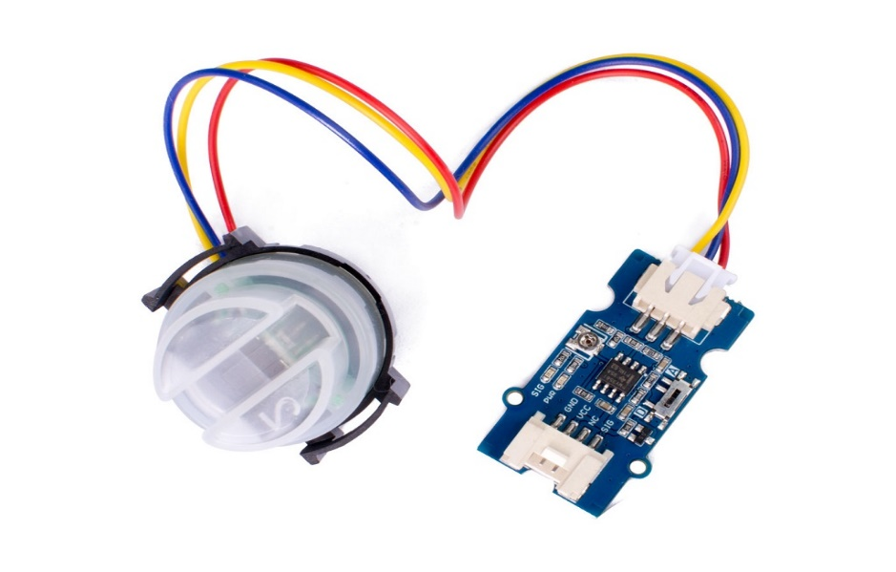

Fig-3.4 Turbidity metre

Turbidity meters typically use either nephelometry or turbidimetry methods to measure turbidity. Nephelometry measures the amount of light scattered at a 90-degree angle from a light source, while turbidimetry measures the amount of light absorbed by suspended particles in the water. Turbidity meters are used in a variety of applications, including drinking water treatment, wastewater treatment, and environmental monitoring. They provide a quick and accurate way to assess the level of contamination or pollution in water and can help to identify potential health risks associated with drinking or using contaminated water.

In summary, turbidity meters are an important tool in water quality monitoring, providing a way to accurately measure the level of suspended solids in water, and ultimately, ensure the safety and health of individuals and communities that rely on access to clean water.

**PINS**

The specific pin description of a turbidity meter can vary depending on the manufacturer and model of the meter. However, here is a general description of the typical pins found in a turbidity meter:

Power: This pin is used to connect the power supply to the turbidity meter. It may be labeled as VCC or +5V.

Ground: This pin is used to connect the ground of the power supply to the turbidity meter. It may be labelled as GND or 0V.

Analog output: This pin provides an analog output signal that corresponds to the measured turbidity value. The signal may be in the form of a voltage or current, and may require additional calibration or scaling.

Digital output: Some turbidity meters may also include a digital output pin, which provides a digital signal that corresponds to the measured turbidity value. The digital signal may be in the form of a serial communication protocol such as RS-232 or I2C.

Calibration: Some turbidity meters may include calibration pins, which are used to calibrate the meter to a specific reference value. These pins may be labelled as CAL or REF.

### 3.5. DHT11 SENSOR

The DHT11 is a basic, ultralow-cost digital temperature and humidity sensor. It uses a capacitive humidity sensor and a thermistorto measure the surrounding air. It spits out a digital signal The pins on a turbidity sensor depend on the specific model and manufacturer of the sensor. However, most turbidity sensors have at least two pins, a power pin and a signal pin. The power pin is used to provide power to the sensor. Typically, turbidity sensors operate at low voltage, and the power pin is connected to a power source, such as a battery or a power supply. The signal pin is used to transmit the sensor's output signal to a microcontroller or other device for processing. The signal may be an analog voltage, which can be read by an analog-to-digital converter (ADC), or a digital signal, which can be read by a digital input pin.

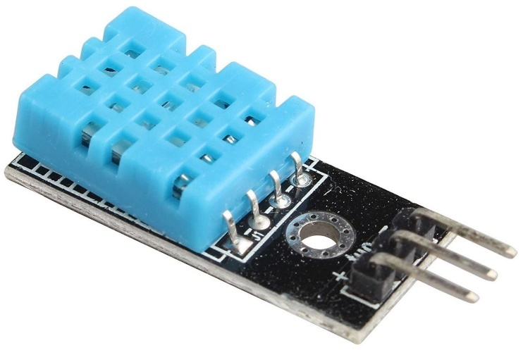

Fig-3.5 DTH11 Sensor

on the data pin. It’s fairly simple to use, but requires careful timing to grab data. The only real downside of this sensor is you can only get new data from it once every 2 seconds. So, when using the library, sensor readings can be up to 2 seconds old. In this project, we will use this sensor to measure the air temperature and humidity. DHT11 sensor consists of a capacitive humidity sensing element and a thermistor for sensing temperature. The humidity sensing [capacitor](https://www.elprocus.com/construction-of-capacitor-with-working/) has two electrodes with a moisture holding substrate as a dielectric between them. Change in the capacitance value occurs with the change in humidity levels. The IC measure, process this changed resistance values and change them into digital form.

The DHT11 sensor comes with a dedicated NTC to measure temperature and an 8-bit microcontroller to output the values of temperature and humidity as serial data. The sensor is also factory calibrated and hence easy to interface with other microcontrollers.

**HISTORY OF DTH11 SENSOR**

The DHT11 sensor is a low-cost, digital humidity and temperature sensor module that was developed by the Chinese company Beijing Huaqiang Electronic Co., Ltd in the early 2000s. The DHT11 is part of the DHT series of sensors that also includes the DHT21 and DHT22 sensors.The DHT11 sensor is designed to measure the relative humidity and temperature of the surrounding environment and provides digital output in a single-wire interface. The sensor has a range of 0-100% relative humidity with an accuracy of ±5% and a temperature range of 0-50°C with an accuracy of ±2°C.

The DHT11 sensor gained popularity due to its low cost, compact size, and ease of use with microcontrollers such as the Arduino. It quickly became a popular choice for hobbyists and DIY electronics enthusiasts who wanted to build projects that required temperature and humidity monitoring.

**WORKING OF DTH11 SENSOR**

The DHT11 sensor is a low-cost, digital temperature and humidity sensor module that works by measuring the relative humidity and temperature of the surrounding environment using a thermistor and a capacitive humidity sensor.

Here is a general overview of how the DHT11 sensor works:

The DHT11 sensor is powered by a voltage supply of 3-5V and requires a pull-up resistor on its data line.The sensor measures the ambient temperature by changing the resistance of a thermistor in response to temperature changes. The thermistor is part of a voltage divider circuit that provides an analog voltage signal to the DHT11's internal microcontroller.The capacitive humidity sensor measures the relative humidity by sensing the amount of moisture in the air. It uses a humidity-sensitive capacitor that changes its capacitance in response to the humidity level.

The DHT11's internal microcontroller converts the analog temperature and humidity signals into digital values by using an analog-to-digital converter (ADC).The DHT11 then sends a 40-bit digital signal to the microcontroller, consisting of a 16-bit relative humidity value, a 16-bit temperature value, and a checksum.The microcontroller uses the received data to calculate the relative humidity and temperature values and then displays or stores the results.It's important to note that the accuracy of the DHT11 sensor can be affected by factors such as ambient temperature, humidity, and power supply voltage fluctuations. Additionally, the DHT11 sensor has a relatively slow response time, which may not be suitable for applications that require fast sensing.

**APPLICATIONS**

The DHT11 sensor is widely used in various applications that require temperature and humidity monitoring. Some of the common applications of the DHT11 sensor include:

1. Home automation: The DHT11 sensor can be used in home automation systems to monitor and control indoor temperature and humidity levels. It can be used to trigger HVAC systems, humidifiers, and dehumidifiers to maintain comfortable and healthy indoor environments.

2. Weather stations: The DHT11 sensor can be used in weather stations to monitor the temperature and humidity levels of the surrounding environment. This information can be used to predict weather patterns and conditions.

3. Agriculture: The DHT11 sensor can be used in agricultural applications to monitor the temperature and humidity levels of soil, crops, and greenhouses. It can be used to optimize crop growth and prevent damage from extreme weather conditions.

4. Industrial control: The DHT11 sensor can be used in industrial control systems to monitor the temperature and humidity levels of manufacturing environments. This information can be used to ensure product quality, reduce energy consumption, and prevent equipment damage.

5. Medical applications: The DHT11 sensor can be used in medical applications to monitor the temperature and humidity levels of hospital rooms and medical equipment. This can help prevent the growth of bacteria and other pathogens and ensure the safety of patients.

**3.5.1 PINS:**

Pin No.

Pin Name

Pin Description

1

VCC

Power supply

to 5.5 Volt DC

3.3

2

DATA

Digital output pin

3

NC

Not in use

Table-3.2 DHT11 Pins

**3.5.2 USES:**

This sensor is used in various applications such as measuring humidity and temperature values in heating, ventilation and air conditioning systems. Weather stations also use these sensors to predict weather conditions. The humidity sensor is used as a preventive measure in homes where people are affected by humidity. It uses a capacitive humidity sensor and a thermistor to measure the surrounding air and spits out a digital signal on the data pin (no analog input pins needed).

## 3.5.3 FEATURES & SPECFICATIONS

1. Operating Voltage: 3.5V to 5.5V
2. Operating current: 0.3mA
3. Output: Serial data
4. Temperature Range: 0°C to 50°C
5. Humidity Range: 20% to 90%
6. Resolution: Temperature and Humidity both are 16-bit
7. Accuracy: ±1°C and ±1%

**3.6. RELAY MODULE**

The relay is the device that open or closes the contacts to cause the operation of the other electric control. It detects the undesirable condition with an assigned area and gives the commands to the circuit breaker to disconnect the affected area through ON or OFF.

**COM:** Common pin

**NO: N**ormally open

There is no contact between the common pin and the normally open pin. So, when you trigger the relay, it connects to the COM pin and power is provided to the load.

**NC**: Normally closed

There is contact between the common pin and the normally closed pin. There is always connection between the COM and NC pins, even when the relay is turned off. When you trigger the relay, the circuit is opened and there is no supply provided to the load. It works on the principle of an electromagnetic attraction. When the circuit of the relay senses the fault current, it energises the electromagnetic field which produces the temporary magnetic field.

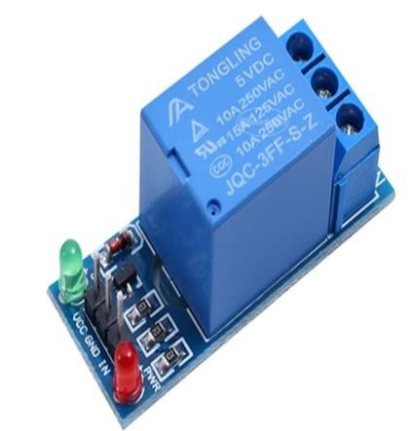This magnetic field moves the relay armature for opening or closing the connections. The small power relay has only one contacts, and the high-power relay has two contacts for opening the switch. The inner section of the relay is shown in the figure below. It has an iron core which is wound by a control coil. The power supply is given to the coil through the contacts of the load and the control switch.

Fig – 3.6 relay module

The current flows through the coil produces the magnetic field around it.

HISTORY OF RELAY MODULE

**3.5.1 PINS:**

Pin – 1 Normally Open (NO)

Pin – 2 Common Contact (CC)

Pin – 3 Normally Closed (NC)

Pin – 4 Signal Pin

Pin – 5 VCC Pin (5V DC)

Pin – 6 Ground Pin (GND)

**3.5.2 USES:**

Relay modules use low-level data signals to switch relays capable of handling loads up to 10 Amps. Ideal for devices like PIR detectors and other sensors that output low level signals that need to turn another device on or off. Great for use with Arduino and other microcontrollers.

Relays are electrically operated switches that open and close the circuits by receiving electrical signals from outside sources. They receive an electrical signal and send the signal to other equipment by turning the switch on and off.

## 3.5.3 FEATURES & SPECFICATIONS

1. Voltage supply range - 5V
2. Quiescent current - 2mA
3. Once the relay is active then the current is ~70mA
4. Highest voltage - 250VAC/30VDC
5. The maximum current - 10A
6. Operating time – 10msec
7. Release time – 5msec

### 3.6. DC MOTOR PUMP

A DC motor is any of a class of rotary [electrical motors](https://en.wikipedia.org/wiki/Electrical_motor) that converts direct current (DC) electrical energy into mechanical energy. The most common types rely on the forces produced by magnetic fields. Nearly all types of DC motors have some internal mechanism, either electro mechanical or electronic, to periodically change the direction of current in part of the motor.

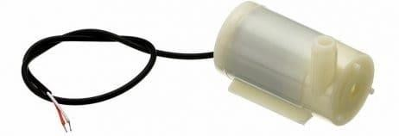

Fig –3.7 DC motor pump

The DC 3-6 V Mini Micro Submersible Water Pump is a low cost, small size Submersible Pump Motor. It operates from a 2.5 ~ 6Vpower supply. It can take up to 120 L/Hr with a very low current consumption of 220mA. Just connect the tube pipe to the motor outlet, submerge it in water, and power it.

**3.6.1 WORKING:**

The water pump works using water suction method which drain the water through its inlet and released it through the outlet. As the engine starts, the impeller turns which forces the water around it out of the pump's discharge port. The partial vacuum created, allows the earth's air pressure to force water up the suction hose (straw), and into the suction (inlet) side of the pump to replace the displaced water.

## 3.6.2 FEATURES & SPECFICATIONS

1. Operating Voltage – 2.5 ~ 6V
2. Operating Current – 130 ~ 220Ma
3. Flow Rate – 80 ~ 120 L/H
4. Maximum Lift – 40 ~ 110 mm
5. Outlet Outside Diameter – 7.5 mm
6. Outlet Inside Diameter – 5 mm.

**3.7. Microsoft IOT Architecture:**

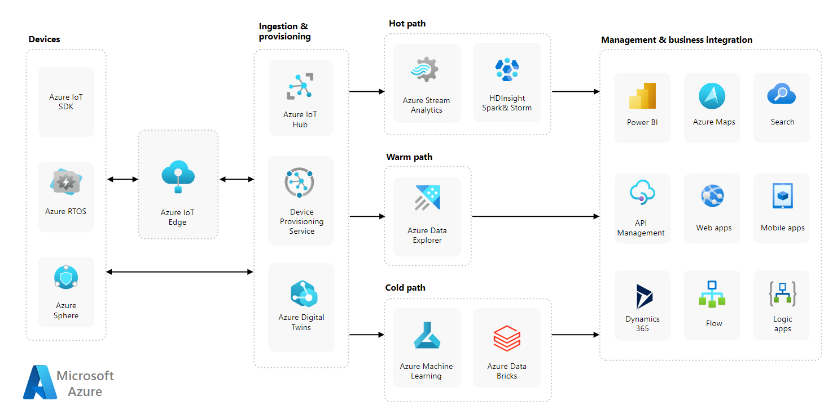

Fig – 8 Azure IOT Architecture

**AZURE IOT SDK**

The Azure IoT device SDKs include a set of device client libraries, samples, and documentation. The device SDKs simplify the process of programmatically connecting devices to Azure IoT.

**AZURE RTOS**

Azure RTOS is an embedded development suite including a small but powerful operating system that provides reliable, ultra-fast performance for resource-constrained devices.

**AZURE SPHERE**

Azure sphere is a secured, high-level application platform with built-in communication and security features for internet-connected devices

**AZURE IOT EDGE**

IoT Edge modules are containers that run Azure services, third-party services, or custom code. They are deployed to IOT edge-enabled devices and execute locally on those devices.

**INGESTION&PROVISION**

**AZURE IOT HUB**

Azure IOT Hub is a managed service hosted in the cloud that acts as a central message hub for communication between an IOT application and its attached devices.

**DEVICE PROVISIONING SERVICE**

The IOT Hub Device Provisioning Service (DPS) is a helper service for IOT Hub that enables zero-touch, just-in-time provisioning to the right IOT hub without requiring human intervention.

**AZURE DIGITAL TWINS**

Azure digital twins is an internet of things (IoT) platform that enables you to create a digital representation of real-world items, places, business processes, and people.

**HOT PATH**

**AZURE STREAM ANALYTICS**

Azure stream analytics is a fully managed stream processing engine designed to analyze and process a large volume of streaming data with sub-millisecond latencies.

**HDINSIGHT SPARK&STORM**

Azure HDInsight is a managed, full-spectrum, open-source analytics service in the cloud for enterprises. It enables you to protect your enterprise data assets with an azure virtual network, encryption, and integration with azure active directory.

**WARM PATH**

**AZURE DATA EXPLORER**

Azure data explorer is a fast, fully managed data analytics service for real-time analysis of large volumes of data streaming from applications, websites, IoT devices, and more.

**COLD PATH**

**AZURE MACHINE LEARNING**

Azure machine learning is a cloud service for accelerating and managing the machine learning project lifecycle.

**AZURE DATA BRICKS**

Azure data bricks provide the latest version of Apache spark and allow you to seamlessly integrate with open-source libraries.

**MANAGEMENT & BUSINESS INTEGRATION**

**POWER BI**

Power BI is a unified, scalable platform for self-service and enterprise business intelligence (BI). Connect to and visualize any data.

**API MANAGEMENT**

API management is the process of designing, publishing, documenting, and analysing APIs in a secure environment.

**DYNAMICS 365**

Dynamics 365 is a portfolio of intelligent business application that delivers superior operational efficiency.

**AZURE MAPS**

Azure maps is a set of geospatial services and SDKs that employ real-time mapping data to provide online and mobile apps with a geographic perspective.

**WEB APPS**

Web apps is an application program that is stored on a remote server and delivered over the internet through a browser interface.

**FLOW**

To issue or move in a stream.

**SEARCH**

An act of boarding and inspecting a ship on the high seas in the exercise of the right of search.

**MOBILE APPS**

A mobile app or application is a software application developed specifically for use on small, wireless computing devices, such as smartphones and tablets. Azure logic apps is a cloud service. Using logic apps define the workflow.

**LOGIC APPS**

At ease consuming a range of APIs exposed as connectors

**CHAPTER – 4**

# SOFTWARE PROCEDURE

## 4.1. INTERNET OF THINGS

The Internet of things (IoT) describes physical objects (or groups of such objects) with [sensors,](https://en.wikipedia.org/wiki/Sensor) processing ability, [software](https://en.wikipedia.org/wiki/Software) and other technologies that connect and exchange data with other devices and systems over the [Internet](https://en.wikipedia.org/wiki/Internet) or other communications networks. Internet of things has been considered a [misnomer](https://en.wikipedia.org/wiki/Misnomer) because devices do not need to be connected to the public internet, they only need to be connected to a network and be individually addressable.

The field has evolved due to the convergence of multiple [technologies,](https://en.wikipedia.org/wiki/Technologies) including [ubiquitous computing,](https://en.wikipedia.org/wiki/Ubiquitous_computing) [commodity](https://en.wikipedia.org/wiki/Commodity) [sensors,](https://en.wikipedia.org/wiki/Sensors) increasingly powerful [embedded systems,](https://en.wikipedia.org/wiki/Embedded_system) as well as [machine learning.](https://en.wikipedia.org/wiki/Machine_learning) Traditional fields of [embedded systems,](https://en.wikipedia.org/wiki/Embedded_system) [wireless sensor networks,](https://en.wikipedia.org/wiki/Wireless_sensor_network) control systems, [automation](https://en.wikipedia.org/wiki/Automation) (including [home](https://en.wikipedia.org/wiki/Home_automation) and [building automation)](https://en.wikipedia.org/wiki/Building_automation), independently and collectively enable the Internet of things.

In the consumer market, IoT technology is most [synonymous](https://en.wikipedia.org/wiki/Synonymous_(disambiguation)) with products pertaining to the concept of the "[smart home"](https://en.wikipedia.org/wiki/Smart_home_technology), including devices and [appliances](https://en.wikipedia.org/wiki/Home_appliance) (such as lighting fixtures, [thermostats,](https://en.wikipedia.org/wiki/Thermostats) home [security systems,](https://en.wikipedia.org/wiki/Security_systems) cameras, and other home appliances) that support one or more common ecosystems, and can be controlled via devices associated with that ecosystem, such as [smartphones](https://en.wikipedia.org/wiki/Smartphone) and [smart speakers.](https://en.wikipedia.org/wiki/Smart_speaker) IoT is also used in [healthcare systems.](https://en.wikipedia.org/wiki/Health_system)

There are a number of concerns about the risks in the growth of IoT technologies and products, especially in the areas of [privacy](https://en.wikipedia.org/wiki/Digital_privacy) and [security,](https://en.wikipedia.org/wiki/Digital_security) and consequently, industry and governmental moves to address these concerns have begun, including the development of international and local standards, guidelines, and regulatory frameworks.

### Types of IOT Networks

1. Cellular networks use the same mobile networks
2. Local and Personal Area Networks (LAN/PAN)
3. Low Power Wide Area Networks (LPWAN)
4. Mesh Networks.

**4.2. ADVANTAGES OF IOT**

**1. Minimize human effort:**

As IoT devices interact and communicate with each other, they can automate the tasks helping to improve the quality of a business’s services and reducing the need for human intervention.

**2. Save time:**

By reducing the human effort, it saves a lot of our time. Saving time is one of the primary advantages of using the IoT platform.

**3. Enhanced data collection:**

Information is easily accessible, even if we are far away from our actual location, and it is updated frequently in real-time. Hence these devices can access information from anywhere at any time on any device.

1. **Improved security:**

If we have an interconnected system, it can assist in the smarter control of homes and cities through mobile phones. It enhances security and offers personal protection.

1. **Efficient resource utilization:**

We can increase resource utilization and monitor natural resources by knowing the functionality and how each device works.

**6. Reduced use of other electronic equipment:**

Electric devices are directly connected and can communicate with a controller computer, such as a mobile phone, resulting in efficient electricity use. Hence, there will be no unnecessary use of electrical equipment.

**7. Use in traffic systems:**

Asset tracking, delivery, surveillance, traffic or transportation tracking, inventory control, individual order tracking, and customer management can be more cost-effective with the right tracking system using IoT technology.

**8. Useful for safety concerns:**

It is helpful for safety because it senses any potential danger and warns users. For example, GM OnStar is an integrated device that identifies a car crash or accident on the road. It immediately makes a call if an accident or crash is found.

**9. Useful in the healthcare industry:**

Patient care can be performed more effectively in real-time without needing a doctor’s visit. It gives them the ability to make choices as well as provide evidence-based care.

**4.3. DISADVANTAGES OF IOT**

**1.Security issues:**

IoT systems are interconnected and communicate over networks. So, the system offers little control despite any security measures, and it can lead to various kinds of network attacks.

1. **Privacy concern:**

The IoT system provides critical personal data in full detail without the user’s active participation.

1. **Increased unemployment:**

Unskilled workers or even the skilled ones are at a high risk of losing their jobs, leading to high unemployment rates. Smart surveillance cameras, robots, smart ironing systems, smart washing machines, and other facilities are replacing the humans who would earlier do these works.

1. **The complexity of the system:**

The designing, developing, maintaining, and enabling the extensive technology to IoT system is quite complicated.

1. **High chances of the entire system getting corrupted:**

If there is a bug in the system, it is possible that every connected device will become corrupted.

1. **Lack of international standardizations:**

As there is no international standard of compatibility for IoT, it is problematic for devices from different manufacturers to communicate with each other.

1. **High dependency on the internet:**

They rely heavily on the internet and cannot function effectively without it.

1. **Reduced mental and physical activity:**

Overuse of the internet and technology makes people ignorant because they rely on smart devices instead of doing physical work, causing them to become lethargic and inactive.

**4.4. IOT APLLICATIONS**

#### 1. Wearables

Wearable technology is a hallmark of IoT applications and probably is one of the earliest industries to have deployed the IoT at its service. We happen to see Fit Bits, heart rate monitors and smartwatches everywhere these days.

One of the lesser-known wearables includes the Guardian glucose monitoring device. The device is developed to aid people suffering from diabetes. It detects glucose levels in the body, using a tiny electrode called glucose sensor placed under the skin and relays the information via Radio Frequency to a monitoring device.

#### 2. Smart Home Applications

Smart Homes are probably the first thing that we think of. The best example I can think of here is Jarvis, the AI home automation employed by Mark Zuckerberg. There is also

Allen Pan’s Home Automation System where functions in the house are actuated by use of a string of musical notes. The following video could give you a better idea.

#### 3. Health Care

The resources that current medical research uses, lack critical real-world information. It mostly uses leftover data, controlled environments, and volunteers for medical examination. IoT opens ways to a sea of valuable data through analysis, real-time field data, and testing. The Internet of Things also improves the current devices in power, precision, and availability. IoT focuses on creating systems rather than just equipment.

#### 4. Smart Cities

The thing about the smart city concept is that it’s very specific to a city. The problems faced in Mumbai are very different than those in Delhi. The problems in Hong Kong are different from New York. Even global issues, like finite clean drinking water, deteriorating air quality and increasing urban density, occur in different intensities across cities. Hence, they affect each city differently.

#### 5. Agriculture

Statistics estimate the ever-growing world population to reach nearly 10 billion by the year 2050. To feed such a massive population one needs to marry agriculture to technology and obtain best results. There are numerous possibilities in this field. One of them is the Smart Greenhouse.

A greenhouse farming technique enhances the yield of crops by *controlling environmental parameters*. However, manual handling results in production loss, energy loss, and labor cost, making the process less effective.

A greenhouse with embedded devices not only makes it easier to be monitored but also, enables us to control the climate inside it. Sensors measure different parameters according to the plant requirement and send it to the cloud. It, then, processes the data and applies a control action.

#### 6. Industrial Automation

This is one of the fields where both faster developments, as well as the quality of products, are the critical factors for a higher Return on Investment. With IoT Applications, one could even re-engineer products and their packaging to deliver better performance in both cost and customer experience. IoT here can prove to be game changing with solutions for all the following domains in its arsenal.

1. Factory Digitalization
2. Product flow Monitoring
3. Inventory Management
4. Safety and Security
5. Quality Control
6. Packaging optimization
7. Logistics and Supply Chain Optimization